**JAVA FUNDAMENTALS SECTION-6:**

Creating an Inventory Project

-B.Rishitha

192324130

Topics:

* Using loops
* Handling Exceptions
* Using if statements
* Arrays of objects

Problem Statement:

Create an inventory program that can be used for a range of different products.

Code:

import java.util.InputMismatchException;

import java.util.Scanner;

public class ProductTester {

public static void main(String[] args) {

Scanner scanner = new Scanner(System.in);

int maxSize = -1;

do {

try {

System.out.print("Enter the number of products you would like to add: ");

maxSize = scanner.nextInt();

if (maxSize < 0) {

System.out.println("Incorrect Value entered. Please enter a positive integer or 0.");

}

} catch (InputMismatchException e) {

System.out.println("Incorrect data type entered! Please enter a valid integer.");

scanner.next();

} catch (Exception e) {

System.out.println("An error occurred: " + e.getMessage());

scanner.next();

}

} while (maxSize < 0);

if (maxSize == 0) {

System.out.println("No products required!");

} else {

Product[] products = new Product[maxSize];

for (int i = 0; i < maxSize; i++) {

System.out.print("Enter product " + (i + 1) + " name: ");

String name = scanner.next();

System.out.print("Enter product " + (i + 1) + " quantity: ");

int quantity = scanner.nextInt();

System.out.print("Enter product " + (i + 1) + " price: ");

double price = scanner.nextDouble();

System.out.print("Enter product " + (i + 1) + " item number: ");

int itemNumber = scanner.nextInt();

products[i] = new Product(name, quantity, price, itemNumber);

}

System.out.println("Product Information:");

for (int i = 0; i < maxSize; i++) {

System.out.println("Product " + (i + 1) + ":");

System.out.println("Name: " + products[i].getName());

System.out.println("Quantity: " + products[i].getQuantity());

System.out.println("Price: " + products[i].getPrice());

System.out.println("Item Number: " + products[i].getItemNumber());

System.out.println();

}

}

}

}

class Product {

private String name;

private int quantity;

private double price;

private int itemNumber;

public Product(String name, int quantity, double price, int itemNumber) {

this.name = name;

this.quantity = quantity;

this.price = price;

this.itemNumber = itemNumber;

}

public String getName() {

return name;

}

public int getQuantity() {

return quantity;

}

public double getPrice() {

return price;

}

public int getItemNumber() {

return itemNumber;

}

}

Output:

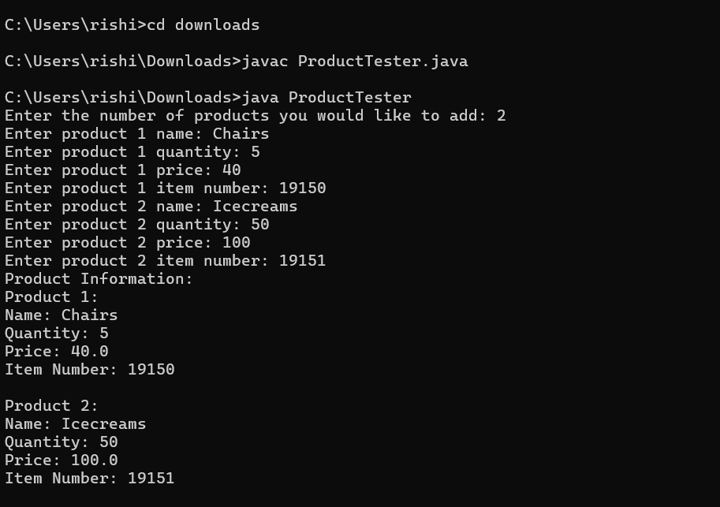

**Outputs with exceptions implementation:**

